A rebuttal to Watters et al. ´2020 Long-term observations from Antarctica demonstrate that mismatched scales of fisheries management and predator-prey interaction lead to erroneous conclusions about precaution´

2025-10-17

Abstract

Characterising the impact of human activities on wildlife is a key function of applied science. In the Antarctic Peninsula, the fishery for Antarctic krill has been operating for over half a century, and concerns that fishery-driven localised depletion of krill around pygoscelid penguin colonies could have deleterious effect on their performance and demographic trends have been raised. One study utilises 30 years of penguin foraging and reproductive performance of penguins at two colonies in the South Shetland Islands matched against acoustic measurements of krill biomass and krill catches at the gSSMU scale (Watters, Hinke, and Reiss 2020). Herein we provide an assessment of the efficacy of this approach in drawing conclusions as representing sound scientific advice, given that the study in question is now being used as such. We demonstrate that several underlying assumptions in the Watters et al. 2020 study are contrary to the published scientific literature and not supported by the data provided by the authors themselves. When the modelling appraoch is reformulated to account for these inaccuracies, we demonstrate that the impact on penguin performance of fishing activity is greatly reduced, and that the dominant driver of penguin performance is the Oceanic Niño Index. We conclude that the original study should be treated with caution when used as a basis for fisheries management advice.

# Introduction

Concerns over the potential impact of localised depletion of krill through concentrated fishing effort on krill-dependent predators has been a topic of debate within the Antarctic science community for many years. Recently, one study has been presented that suggest that local harvesting rates can impact predator performance to the same degree as poor environmental conditions (Watters, Hinke, and Reiss 2020) by matching various performance indices of krill-dependent penguins relative to estimates of krill biomass, fishing pressure and broad scale climate variability. The penguin performance indices were collected at two sites (Cape Shireff on Livingstone Island and Copacabana on King George Island, South Shetland Islands; Figure 1) in the period 1982 - 2016 whereas krill abundance data, which cover the at-sea distributions of chinstrap, gentoo and Adélie penguins, were collected during summer (1996 - 2011) and winter (2012, 2014 and 2015). By drawing in monthly krill catches from Catch and Effort data reported to CCAMLR and climate data (ONI), the authors use a hierarchical analysis of variance approach to estimate the variance in these indices as a function of Local Krill Biomass (LKB), Local Harvesting Rates (LHR; the ratio of krill catch to LKB) and the Oceanic Niño Index (ONI). The study drew the conclusion that local harvesting levels of krill adversely impact penguins, and the degree of impact can either be similar to that of poor environmental conditions or have a synergistic impact when high local harvesting coincides with poor conditions. The conclusions of this paper, which at the time of writing has accumulated 162 citations, have been used by CCAMLR in support of developing Marine Protected Area proposals and fisheries management strategies as well as being used in the review process of the Marine Stewardship Council fisheries certification process for Antarctic krill. In other words, the outcomes of this study have been propagated into geopolitical and socioeconomic environments that are having real-world impacts beyond a scientific debate. However, we have identified six critical issues that undermine the validity of Watters et al. (2020). We provide a brief description of the background behind each issue and a summarizing statement of the problem.

## *Continuing spatial and temporal mismatches predators and fishing activity*

A key goal for Watters et al. (2020) was to highlight the consequences of mismatching scales at which the Antarctic krill fishery is managed with the scales at which ecological interactions between fishing extractions and dependent predators occur. To do this, the authors created two strata aligned with groups of SSMU (gSSMU); gSSMU #1 including those SSMU inside the Bransfield Strait (APBSE and APBSW) and gSSMU #2 incorporating SSMU north of the South Shetlands, including Elephant Island (APDPE, APDPW and APEI) represented in Figure 1. These gSSMU cover and , respectively, and are used to characterise both krill biomass and harvesting rates that are “local” to the penguin colonies for which performance data are used. The reasoning behind scaling to gSSMU are linked to the foraging behaviour of the penguins for which performance data area available i.e. breeding, adult pygoscelids. The authors cite Hinke et al. (2017) as the evidence supporting usage of the two gSSMU as appropriate strata. Pygoscelid penguins also exhibit staggered breeding, with Adélies commencing first, followed by chinstraps then gentoos (Black 2016). Adélie penguins are the first to fledge their chicks and thus cease to be centrally foraging, typically departing early February for their moulting grounds on the sea ice. chinstrap penguins depart for a pre-moult foraging trip towards the start of February and return to land in order to moult, before departing again for their overwinter trip mid-March (Hinke et al. 2015); Hinke et al. 2019). Conversely, gentoo penguins appear to remain near their breeding colonies overwinter (Korczak-Abshire et al. 2021).

*The model used by Watters et al. (2020) presumes that penguins occupy the entire gSSMU they are assigned to throughout the entire year.*

## *Unsupported ecological assumptions*

The study’s conclusions are also compromised by unvalidated ecological assumptions, particularly the assertion that krill biomass at spatial scales relevant to penguins varies with the phase of the Southern Annular Mode (SAM). While SAM is known to influence large-scale atmospheric circulation and sea ice extent (REF), its direct relationship to local krill biomass, especially at the scales relevant to penguin foraging, has not been empirically validated. The assumption that SAM-driven variability in krill biomass uniformly affects penguin performance across broad regions ignores the complexity of local oceanographic and biological processes. For instance, krill recruitment and aggregation are influenced by a multitude of factors, including local prey availability, predation pressure, and fine-scale hydrodynamic features, which are not captured by SAM alone (REF). Without robust empirical support for this assumption, the study’s findings regarding the interaction between climate, krill biomass, and penguin performance remain speculative. Addressing this gap requires finer-scale data on krill distribution and environmental drivers to validate, or refute, the proposed mechanisms underlying the study’s conclusions.

*KEY PROBLEM STATEMENT - JAVIER*

## *Coding errors*

A coding error further distorts the study’s findings: the “Worst Case” scenario is described in the text as having a neutral Oceanic Niño Index (ONI) but is incorrectly coded using a warm ONI parameter set (Supplementary Material 1, lines 661–663). This misclassification affects the interpretation of the model’s outputs, particularly the marginal probabilities associated with the “Worst Case” scenario.

*Structural coding errors have created misleading results presented in the published article.*

## *Omission of competing species*

Another significant limitation of Watters et al. (2020) is its failure to account for competing krill-dependent predators, such as recovering whale populations (Baines et al.2021; Biuw et al. 2024) and migratory male Antarctic fur seals (Lowther et al.2020). These species compete directly with penguins for krill, particularly in key foraging areas like the Bransfield Strait and Gerlache Strait (e.g. Hückstädt et al. 2012; Johannessen et al. 2022). By ignoring the presence and consumption demands of these predators, the study overestimates the relative impact of the krill fishery on penguin performance. For example, whales and seals can substantially reduce local krill availability, potentially exacerbating any effects of fishing pressure. Without considering these competing factors, the study’s conclusions about the impacts of localized krill harvesting on penguins are incomplete and potentially misleading. A comprehensive assessment of fishery impacts must incorporate the full suite of krill-dependent predators to accurately evaluate competition dynamics and their consequences for penguin populations.

T*he model used by Watters et al. (2020) neglects the impact of recovering populations of large-bodied krill eating predators that overlap in time and space with penguins beyond a cursory discussion.*

## *Model bias*

The analysis in Watters et al. (2020) suffers from two critical methodological flaws that undermine its conclusions. First, the model includes both Local Krill Biomass (LKB) and Local Harvest Rate (LHR) as separate predictors, despite LHR being mathematically derived from LKB (LHR = Catch / LKB). This structural confounding introduces multicollinearity, making it impossible to isolate the independent effects of krill availability and fishing pressure on penguin performance. For example, areas with low LKB will inherently yield higher LHR values even for modest catches, artificially inflating the perceived impact of fishing pressure.

*PROBLEM STATEMENT - ULF*

## *Over-reliance on broad-scale climate indices*

A further limitation of Watters et al. (2020) is its reliance on macroscale climate indices, such as the Oceanic Niño Index (ONI) and the Southern Annular Mode (SAM), to explain variability in krill availability and penguin performance. the utilisation of broad-scale climatological phenomena to characterise impacts at scales that predators are dependent upon is problematic. The Amundsen Sea Low (ASL) is the dominant climate feature for the western Antarctic Peninsula. The El Niño-Southern Oscillation (captured in the ONI predictor) modulates the ASL, with El Niño (La Niña) shallowing (deepening) its pressure, causing more northwesterly (southeasterly) winds and upwelling (restricted influx) of Circumpolar Deep Water onto the shelf. The SAM also influences the pressure of the ASL, with the current trend of negative SAM constructively (destructively) interfering with ASL when in phase with El Niño (La Niña) events (e.g. Clem et al. 2016). The result is a set of above-surface climate conditions that drive changes in water mass intrusion that is in turn dependent on interactions between two climate processes as well as the geographical orientation of the coastline involved, all of which have been shown to impact the foraging trajectories and trip durations of Chinstrap penguins (Andrew D. Lowther et al. 2018). The bathymetry of the Antarctic Peninsula, which also influences the hydrographic conditions, is complex particularly at scales that are important to centrally-foraging predators such as penguins. The structuring of krill aggregations in time and space in the WAP have also been linked to mesoscale circulation processes (Santora et al. 2012), which are unlikely to be uniformly affected by macroscale processes given variation in local bathymetric and coastal orientation. It is also worth noting that the study considers neither the impact of climate on the terrestrial breeding grounds, such as chick mortality through “wetting down” by increased rainfall (Chapman et al. 2011) nor the unaccounted-for measurement inaccuracies in the foraging trip durations used by Watters et al. 2020 (Lowther et al. 2015). While these indices provide useful insights into large-scale atmospheric and oceanographic patterns, they fail to capture the finer-scale processes that directly influence krill distribution and predator-prey interactions. For example, mesoscale oceanographic features, such as local upwelling, sea ice dynamics, and bathymetric influences, play a critical role in determining krill aggregation and accessibility to penguins (REF). However, these processes operate at spatial and temporal scales that are not adequately reflected by broad indices like ONI or SAM (REF). As a result, the study’s conclusions about the impacts of climate variability on penguin performance may be oversimplified or misrepresented, particularly in regions where local environmental conditions deviate from large-scale climate patterns. This overreliance on coarse climate indices limits the study’s ability to accurately assess the true drivers of krill availability and, consequently, penguin responses to environmental change. As such, the general structure of the study does not appear to be appropriate for answering the research questions raised.

*The model used by Watters et al. (2020) relies exclusively on ocean-scale climate indices as environmental predictors of LKB and penguin performance.*

Herein, we conduct analyses and discuss these to demonstrate the inappropriate or unsupported conclusions related to Issues #1 to #3 and the potential impact that Issue #4 raises in understanding the drivers of penguin performance. We then discuss Issues #5 and #6 qualitatively, with no associated numerical analyses.

# Materials and Methods

## *Continuing spatial and temporal mismatches*

predators and fishing activity We use the Argos-CLS PTT telemetry data provided by the supporting studies in Watters et al. (2020) to characterise the actual at-sea habitat used, in the context of the relative stage of breeding for each species, though we also recommend Warwick-Evans et al. (2018) and Lowther et al. (2018) amongst other work, for further quantification of foraging behaviour of breeding penguins in this area. For each species, we refrain from undertaking extensive state-space modelling of location errors and merely exclude locations with a “Z” error class, accepting the remaining locations had varying degrees of uncertainty around them. We then calculated the 99% Minimum Convex Polygon (home range) using the R package adehabitatHR and calculate their associated areas in , with the resulting MCP likely being larger than the area actually exploited, given the remaining inaccuracy in the underlying locations used.

We then scale the gSSMU LKB to the SSMU that the summer tracking data indicate penguins occupied. To do this, we calculate the area () of the SSMU for which the predator occupies and the gSSMU to which it is assigned, then create a scaling ratio. For example, we scale LKB for Cape Shireff chinstrap penguins solely to ADPDW (Figure 1) by multiplying the gSSMU LKB by the areal ratio of ADPDW/gSSMU #2. We then select the corresponding SSMU catch values provided in Watters et al. (2020) (Supplementary Info) to estimate SSMU-scale LHR. We also caution that while considering the gSSMU scale of harvesting as inappropriate for “local” effects, even the SSMU-scale catch levels likely do not reflect pressures at scales relevant to breeding penguins. The authors place LKB/LHR values in March into the “summer” period, thus effectively incorporating fishing pressure into the summer breeding season in the context of penguin performance metrics. However fishing effort over the period that performance indices are available is not uniform over the thirty year period, with catch over the preceding decade tending towards a nonlinear increase from the middle of March and three years where catch rates increased rapidly from the beginning of March (Figure 4). Given the highly variable rates of catch throughout the study period, we run scenarios that classify March as either summer or winter to reflect the linkage between March and the breeding state of penguins i.e. Adélie and chinstrap penguins have either migrated out of the area or have ceased to be centrally foraging species by March (HINKE REFS GALORE, INCLUDING 2025 Scientific Reports).

Thus we reformulate the underlying assumptions above into a new model construct, in which performance indices from gentoo, chinstrap and Adélie penguins during the summer are included, but Adélie and chinstrap penguins cease to be centrally foraging species after breeding and migrate out of the area. The performance indices are matched in space and time but using SSMU level estimates of LKB and LHR. We re-run the model twice 1) using gappy survey data and 2) including imputed values for LKB in years where survey data are missing. We further consider two alternatives for considering March, either in a) summer or b) winter on each model run.

We present the outputs both in the same boxplot format as Figure 2 in the original manuscript, and as individual cases grouped and colour-coded as ONI “warm” ( 0.5; red), ONI “neutral” (-0.5 < ONI > +0.5; white) and ONI “cold” (< -0.5; blue). We also recreate the original marginal probabilities in Table 1 of Watters et al. (2020), and two additional tables in the same format with the probabilities extracted from our reformulated model, the difference between the latter two tables reflecting whether March is in summer or winter.

## *Unvalidated Ecological Assumptions*

## *Model coding error*

We also note an additional coding error that may influence how the original, unmodified results are interpreted. In summarising the model outputs into boxplots, the text in the paper seemingly classifies the “Worst Case” with “neutral” ONI ( oC < ONI < 0.5 oC; LKB > 1 Mt; and LHR 0.1) and the code relating to developing the original manuscript Figure 2 uses Parameter set 36 from the output dataframe, which actually reflects a “warm” ONI component (> 0.5 oC; LKB > 1 Mt; and LHR 0.1). Yet the discussion in Watters, Hinke, and Reiss (2020) also suggests that the likelihood of their “Worst Case” includes future warming (see Figure 3 below)

We agree that any “Worst Case” should reflect ENSO conditions into the future under a warming climate. However, climate change is likely to increase ENSO in amplitude - both El Niño (ONI “warm”) and La Niña (ONI “cold”) (Capotondi et al. 2015). How this increasing amplitude can be integrated appropriately into the presented modelling framework to match with long-term predicted mean performance of predators has not been explored yet. As such, and for the sake of comparison with the original study, we maintain the authors designation of ONI “neutral” when rendering the “Worst Case” boxplots, though caution that this is unlikely to be a realistic assumption

## *Omission of competing species*

In order to provide numerical context on the potential role baleen whales and Antarctic fur seals may play in regulating penguin performance, we conduct two analyses. Firstly, we use published estimates of the time-evolving abundance and distribution of humpback whales (Megaptera novaeangliae) throughout the Bransfield Strait (Johannessen et al. 2022) to estimate the number of whales present in the SSMU occupied by penguins from Copacabana. We then use conservative per-capita consumption estimates (REF) to derive monthly krill consumption rates and compare these to the SSMU krill catch provided in Watters et al. (2020). Secondly, we use per-capita krill consumption rates for adult male Antarctic fur seals which are known to migrate into the region from as early as January until the beginning of the following summer breeding season (Lowther et al. 2020). The catch limit in the management unit in which the Watters et al. (2020) is conducted was 155,000tonnes/year, and we back-calculate the number of Antarctic fur seals that would need to be present to at least equal the krill removal rate of the fishery.

All analyses are conducted in the R statistical software environment (R 4.5.1), using the original data provided in Watters et al. (2020) or in the published articles cited as supporting evidence. To faciliate reproducibility, the Supplementary Material from the original Watters et al. (2020) article and the Supplementary Material from all necessary supporting articles are hosted in Zenodo repositories (record ID 5040114 and record ID 17347172). A dedicated R script allowing for these data and scripts to be downloaded directly from the repositories is provided in Appendix I. Fully annotated R code, highlighting the modifications and justifications, as well as the code needed to fully reproduce the figures and tables presented here, are also included in the Zenodo repositories.

# Results

## *Continuing spatial and temporal mismatches*

Comparing the original model outputs with ours, relative to the “Best Case”, the probability of negative impacts to penguins due to high LHR dropped precipitously from 93% to 37% (Table 3). In other words, when considering the migration of penguins in accordance with their known ecology (Figure 2), the relative probability of negative impact of LHR drops from a near-certainty to 1-in-3 (Table 2 and 3). At this point, we clarify that the probability of negative impact is not a measure of the scale of the expected impact (i.e. a measure of population decline), but a measure of whether any negative impact is likely to occur. Given the temporal separation between fishing and penguin breeding over the preceding decade, our results are unsurprising.

## *Unvalidated Ecological Assumptions*

## *Model coding error*

## *Omission of competing species*

• Figure 1: Impact of Spatial and Temporal Adjustments on Expected Penguin Performance. Illustrate the combined effect of spatial and temporal corrections on model outputs. Highlight that LHR impacts are overestimated in the original model.

Content: • Boxplots comparing expected penguin performance under: ◦ Original model (gSSMU scales, Adélie/chinstrap penguins included in winter, March as summer). ◦ Revised model (SSMU scales, Adélie/chinstrap penguins excluded in winter, March as winter). • Color-coded by ONI conditions: ◦ Warm (≥0.5°C; red). ◦ Neutral (-0.5°C < ONI < 0.5°C; white). ◦ Cold (<-0.5°C; blue).

• Table 1: Marginal Probabilities of Negative Impacts on Penguin Performance

Content: • Comparison of marginal probabilities for: ◦ Original model (Watters et al., 2020). ◦ Revised model (spatial rescaling to SSMU, temporal adjustments, March as winter). • What to include: • Probability of negative impact from high LHR (original: 93%; revised: 37%). • Probability under “Worst Case” (neutral ONI, high LHR, high LKB). • Dominance of ONI effects in revised model.

Unvalidated Ecological Assumptions • Figure 1: Relationship Between SAM Phases and Local Krill Biomass (LKB). Visually confirm the lack of correlation between SAM and LKB. Support the argument that local processes (e.g., upwelling, bathymetry) are more influential than broad-scale climate indices. Content: • Scatter plots or regression plots showing: ◦ SAM index values (x-axis) vs. Local Krill Biomass (LKB) (y-axis). ◦ Data points for different SAM phases (positive, neutral, negative). ◦ Regression line with R² and p-values indicating no significant relationship (F < 0.975, p > 0.33). • Highlight: Visual demonstration that LKB does not vary predictably with SAM phases.

• Table 1: Statistical Tests for SAM-LKB and Low LKB-Small Krill Relationships

Content:

# Discussion

Our reanalysis of Watters et al. (2020) reveals that the study’s conclusions are based on assumptions not supported by empirical data. By addressing spatial and temporal mismatches, unvalidated ecological assumptions, and methodological biases, we demonstrate that the perceived impacts of krill fishing on penguin performance are significantly overestimated. Specifically, rescaling spatial units from gSSMUs to SSMUs and accounting for penguin migration patterns reduced the probability of negative impacts from high Local Harvest Rates (LHR) from 93% to 37%. Additionally, our findings highlight that broad-scale climate indices (ONI, SAM) are less influential than local oceanographic processes in determining krill availability and penguin performance.

## *Spatial and temporal mismatches undermine study conclusions*

The spatial scales used in Watters et al. (2020) are 4–15 times larger than the actual foraging ranges of penguins. For example, Adélie penguins forage within 1,139 nm², yet the study used gSSMUs of 15,500–20,600 nm² to define “local” krill biomass and harvest rates. This mismatch leads to overestimated localized depletion effects, as the broad spatial units fail to capture the fine-scale interactions between penguins and their prey. Similarly, the study’s temporal assumptions incorrectly associate winter fishing pressure with penguin performance, despite Adélie and chinstrap penguins migrating away from breeding colonies by late February. By excluding these species from winter analyses, we show that the original model’s conclusions about seasonal fishing impacts are misassigned.

## *Unvalidated ecological assumptions*

Watters et al. (2020) assumes that krill biomass varies with the Southern Annular Mode (SAM), yet our statistical tests reveal no significant correlation between SAM phases and Local Krill Biomass (LKB). Similarly, the assumption that low LKB (<1 Mt) correlates with small krill is unsupported. The study’s reliance on SAM and ONI thus oversimplifies the complex, fine-scale interactions driving krill-penguin dynamics. Additionally, the study overlooks the role of krill life-stage dynamics in shaping availability and accessibility for penguins and other predators. Krill populations consist of multiple size classes and age cohorts, each with distinct spatial distributions, seasonal behaviors, and energetic values for predators (REF). For instance, small juvenile krill, which may dominate recruitment pulses, are often less energetically valuable to penguins than larger, older krill (REF). Seasonal and spatial variability in krill size structure (e.g., due to recruitment events or environmental conditions) can significantly influence predator performance (REF), yet these dynamics are not explicitly considered in Watters et al. (2020). By treating krill biomass as a homogeneous metric, the authors ignore critical variations in krill quality and availability that may drive penguin foraging success or failure. Addressing this gap requires life-stage-specific data on krill distribution and predator preferences to refine assessments of how fishing and environmental changes affect penguin populations. Together, these oversights highlight the need for finer-scale ecological data to validate, or refute, the mechanisms underlying the study’s conclusions.

## *Model coding error*

The coding error distorts the study’s findings. The “Worst Case” scenario is described in the text as having a neutral Oceanic Niño Index (ONI) but was incorrectly coded using parameters for a warm ONI. This misclassification inflates the perceived severity of neutral ONI conditions, leading to misinterpretation of the model’s outputs, particularly the marginal probabilities associated with the “Worst Case” scenario. The coding error reduces the probability of negative impacts from high LHR from 93% to 37% (Table 3). This adjustment highlights that fishing pressure effects depend on krill abundance, where low LKB amplifies the perceived impact of LHR, while high LKB masks it. Furthermore, the revised model clarifies that the dominance of ONI over LHR in driving penguin performance becomes evident when structural biases are removed.

## *Omission of competing krill predators*

A major limitation of Watters et al. (2020) is its failure to account for competing krill-dependent predators, such as recovering whale populations and migratory male Antarctic fur seals. Using available abundance, distribution and consumption estimates for competing species, we show that humpback whales consume over five times the amount of krill than taken by the fishery per month. We show that the number of male Antarctic fur seals required to match the LHR of the fishery for each year of the study ranges from as few as zero to as many as 72,000 seals; given the number of seals that are recorded at only two sites in the South Orkney Islands (32,000 individuals) and their movements into the Antarctic Peninsula are well documented (Lowther et al. 2020), there are likely to be significant competitive interactions between migrating seals and breeding penguins. The consumption by whales also overlaps temporally with penguin breeding, unlike the fishery which since 2010 has shifted to a winter fishery (REF). Intuitively then, ignoring the vast amount more krill removed by whales at the same time as breeding penguins are foraging is likely to be greatly overestimating the relative impact of fisheries removal on penguin performance. Future assessments must incorporate multi-species interactions to accurately evaluate the cumulative pressures on krill-dependent predators.

## *Model Bias*

The presence of structural model bias arising from the confounding relationship between covariates (LHR and LKB; LHR=Catch/LKB) was not explicitly explored in this study. This dependency, however, masks the isolated effects of krill availability (LKB) and fishing pressure (Catch) on penguin performance, potentially leading to misleading conclusions about the relative importance of these factors. This structural confounding in the model results in artificial inflation of fishing impacts in areas with low LKB, where even modest catches yield high LHR values, thereby exaggerating the perceived impact of fishing pressure on penguin performance. Conversely, in areas with high LKB, substantial catches may be masked because the same absolute catch results in a lower LHR, underestimating the true effects of fishing. This structural bias undermines the study’s ability to disentangle the true ecological drivers of penguin performance, necessitating a reevaluation of the model’s specifications and assumptions. These findings underscore the necessity for methodological rigor in ecological modeling. Future studies should avoid multicollinearity by using Catch and LKB as separate predictors instead of LHR to isolate the effects of fishing pressure and krill availability. Additionally, validating coding and assumptions is crucial to ensure that scenario classifications align with described conditions and prevent misinterpretation. Finally, reevaluating model specifications to account for structural biases will enable more accurate assessments of the impacts of fishing on predator performance. 6 Over-reliance on broad-scale climate indices Watters et al. (2020) relies on macroscale climate indices (ONI, SAM) to explain variability in krill availability, yet these indices fail to capture finer-scale oceanographic processes (e.g., local upwelling, sea ice dynamics) that directly influence krill aggregation. Our reanalysis shows that local environmental predictors (e.g., sea ice concentration, chlorophyll-a) explain more variance in penguin performance than ONI or SAM. This over-reliance on broad-scale indices limits the study’s ability to accurately assess the true drivers of krill availability and penguin responses to environmental change.

## *Implications for fisheries management*

The real-world implications of Watters et al. (2020) are substantial, as its conclusions have influenced CCAMLR’s Marine Protected Area proposals and fisheries certification processes. However, our findings suggest that the study’s methodological limitations—spatial/temporal mismatches, unvalidated assumptions, and omitted competitors—compromise its validity as a management tool. We recommend that future assessments: 1. Use spatial scales aligned with penguin foraging ranges (SSMUs rather than gSSMUs). 2. Account for penguin migration and seasonal fishing effort. 3. Incorporate competing predators and local environmental drivers. By addressing these issues, managers can develop more robust, evidence-based strategies for balancing krill fisheries with predator conservation.

## *Broader concerns and future directions*

While Watters et al. (2020) raises important questions about fishery impacts, its boundary conditions, focusing solely on fishing and climate, are inadequate for disentangling the relative impacts of multiple stressors on krill-dependent predators. Over 20 years ago, CCAMLR acknowledged that its CEMP program could not distinguish between fishing and climate effects (REF), yet no modifications have been made. Moving forward, integrated monitoring programs that account for competition, local oceanography, and fine-scale predator-prey interactions are essential for informing sustainable fisheries management in the Antarctic.

## *Conclusion*

Our reanalysis demonstrates that the conclusions of Watters et al. (2020) are overly pessimistic due to spatial/temporal mismatches, unsupported ecological assumptions, omitted confounding impacts of competitive predators and methodological biases. While climate variability (ONI) remains a dominant driver of penguin performance, the impacts of krill fishing are far less severe when analyzed at ecologically relevant scales. To ensure objective scientific advice for CCAMLR, future studies must adopt finer spatial/temporal resolutions, incorporate competing predators, and avoid structural biases. Only then can we accurately assess the true impacts of fishing on Antarctic krill-dependent predators.

Summary Table showing what was bullshit, and where to find the analysis and data in our paper.

Statement/Question

Data Source

Support & Significance

Appendix Reference

Does LKB vary with SAM sign and strata ?

Appendix I

No; F < 0.975, p >0.33 all cases

LKB does not vary predictably with SAM

Is low LKB (<1Mt) correlated with small krill ?

Appendix II

No; F < 2.175, p >0.154 all cases

Low LKB in Best Case scenario is inappropriate

Are penguin indices related to ONI/SAM ?

Appendix III

No; see Appendix III Table 1

Penguin indices are not correlated to climate variability indices

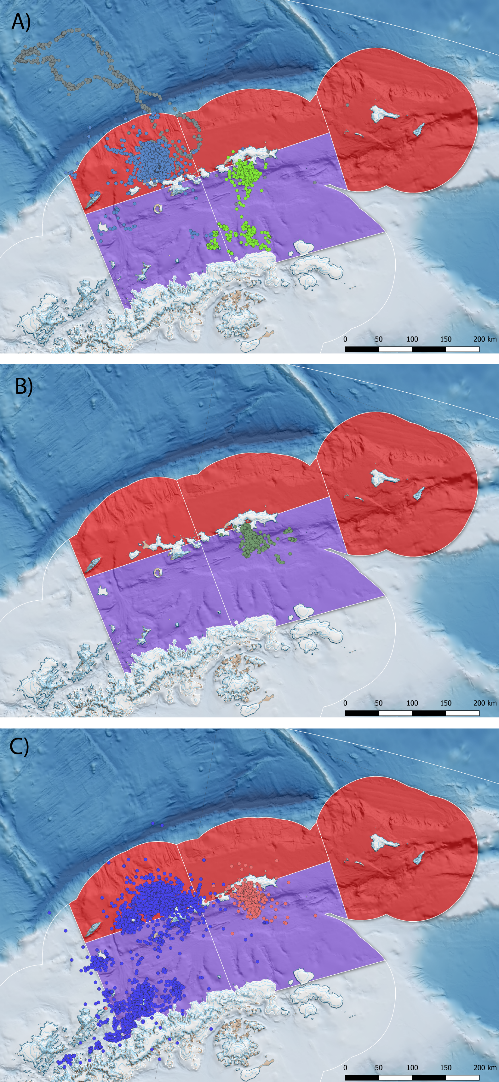

Penguin foraging behaviour during summer breeding, derived from available ARGOS-CLS PTT data presented in Hinke et al. 2017. A) Chinstrap penguins from Cape Shireff (blue) and Copacabana (green) truncated at ${10}^{th}$ March in line with known phenology (Black 2016; Lowther et al.(this meeting). Elongated grey track represents a single animal) B) Adélie penguins truncated to the end of January and C) gentoo penguins until August, representing all available PTT data provided. The SSMU are combined and coloured according to gSSMU (red; gSSMU 2, purple; gSSMU 1) with chinstrap and Adélie penguin 99% MCP home ranges occupying between 7-19% of the gSSMU to which they were assigned.

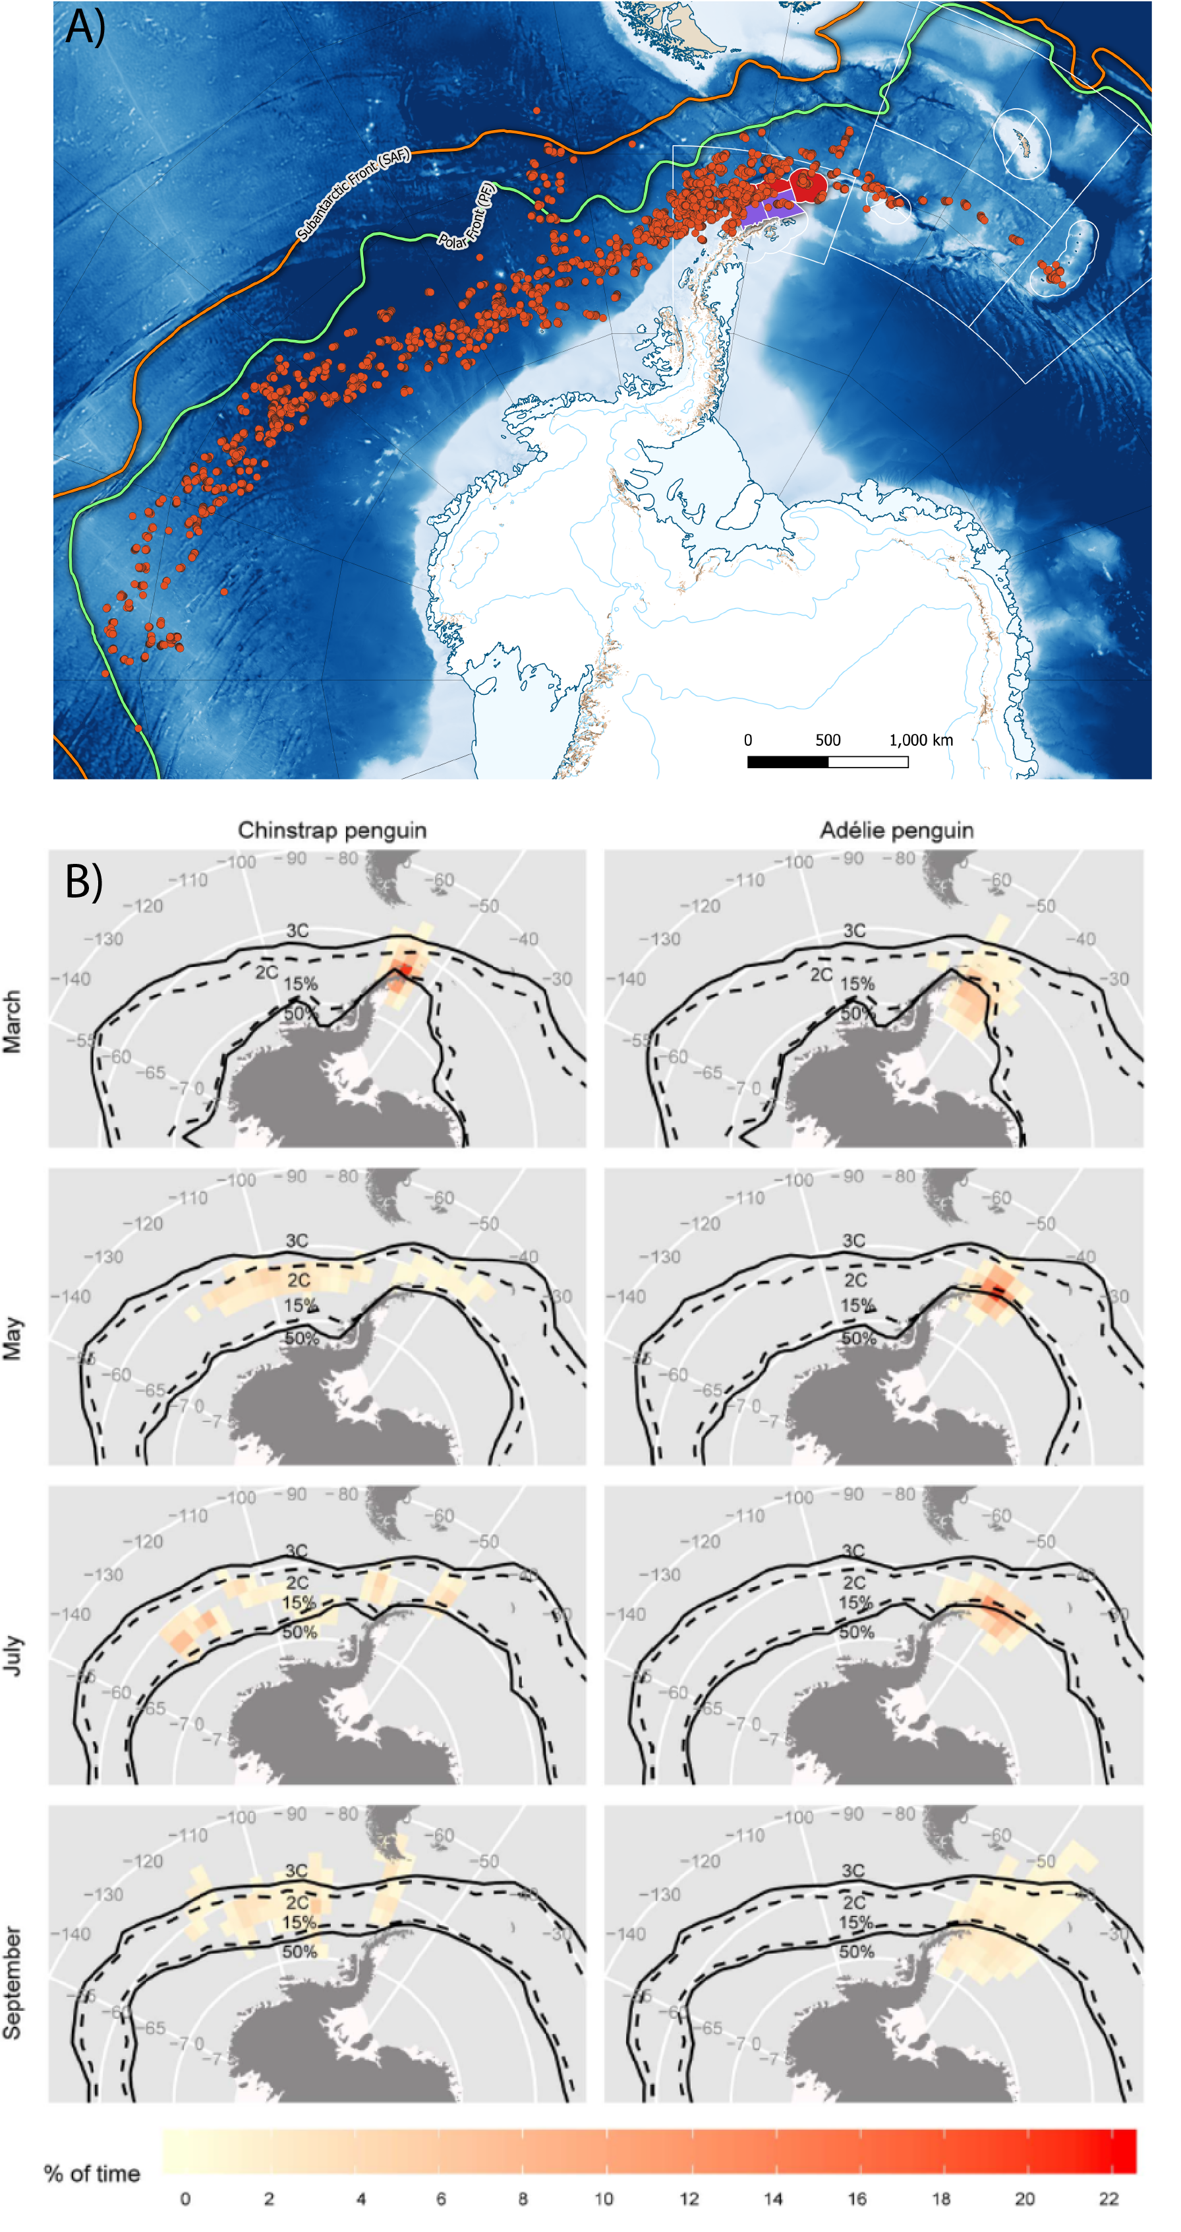

A) Distribution of overwinter movement for chinstrap penguins, relative to the gSSMU’s to which they were attributed, created from telemetry data available in Hinke et al. 2019. B) Adélie and chinstrap penguin movement recorded by light geolocators, highlighting the large longitudinal range both species disperse through at the end of breeding (taken from Hinke et al. 2015). In the original model formulation by Watters et al. 2020, the winter performance indices for both species are matched to macroscale levels of ONI variability but gSSMU-scale estimates of LKB and LHR.

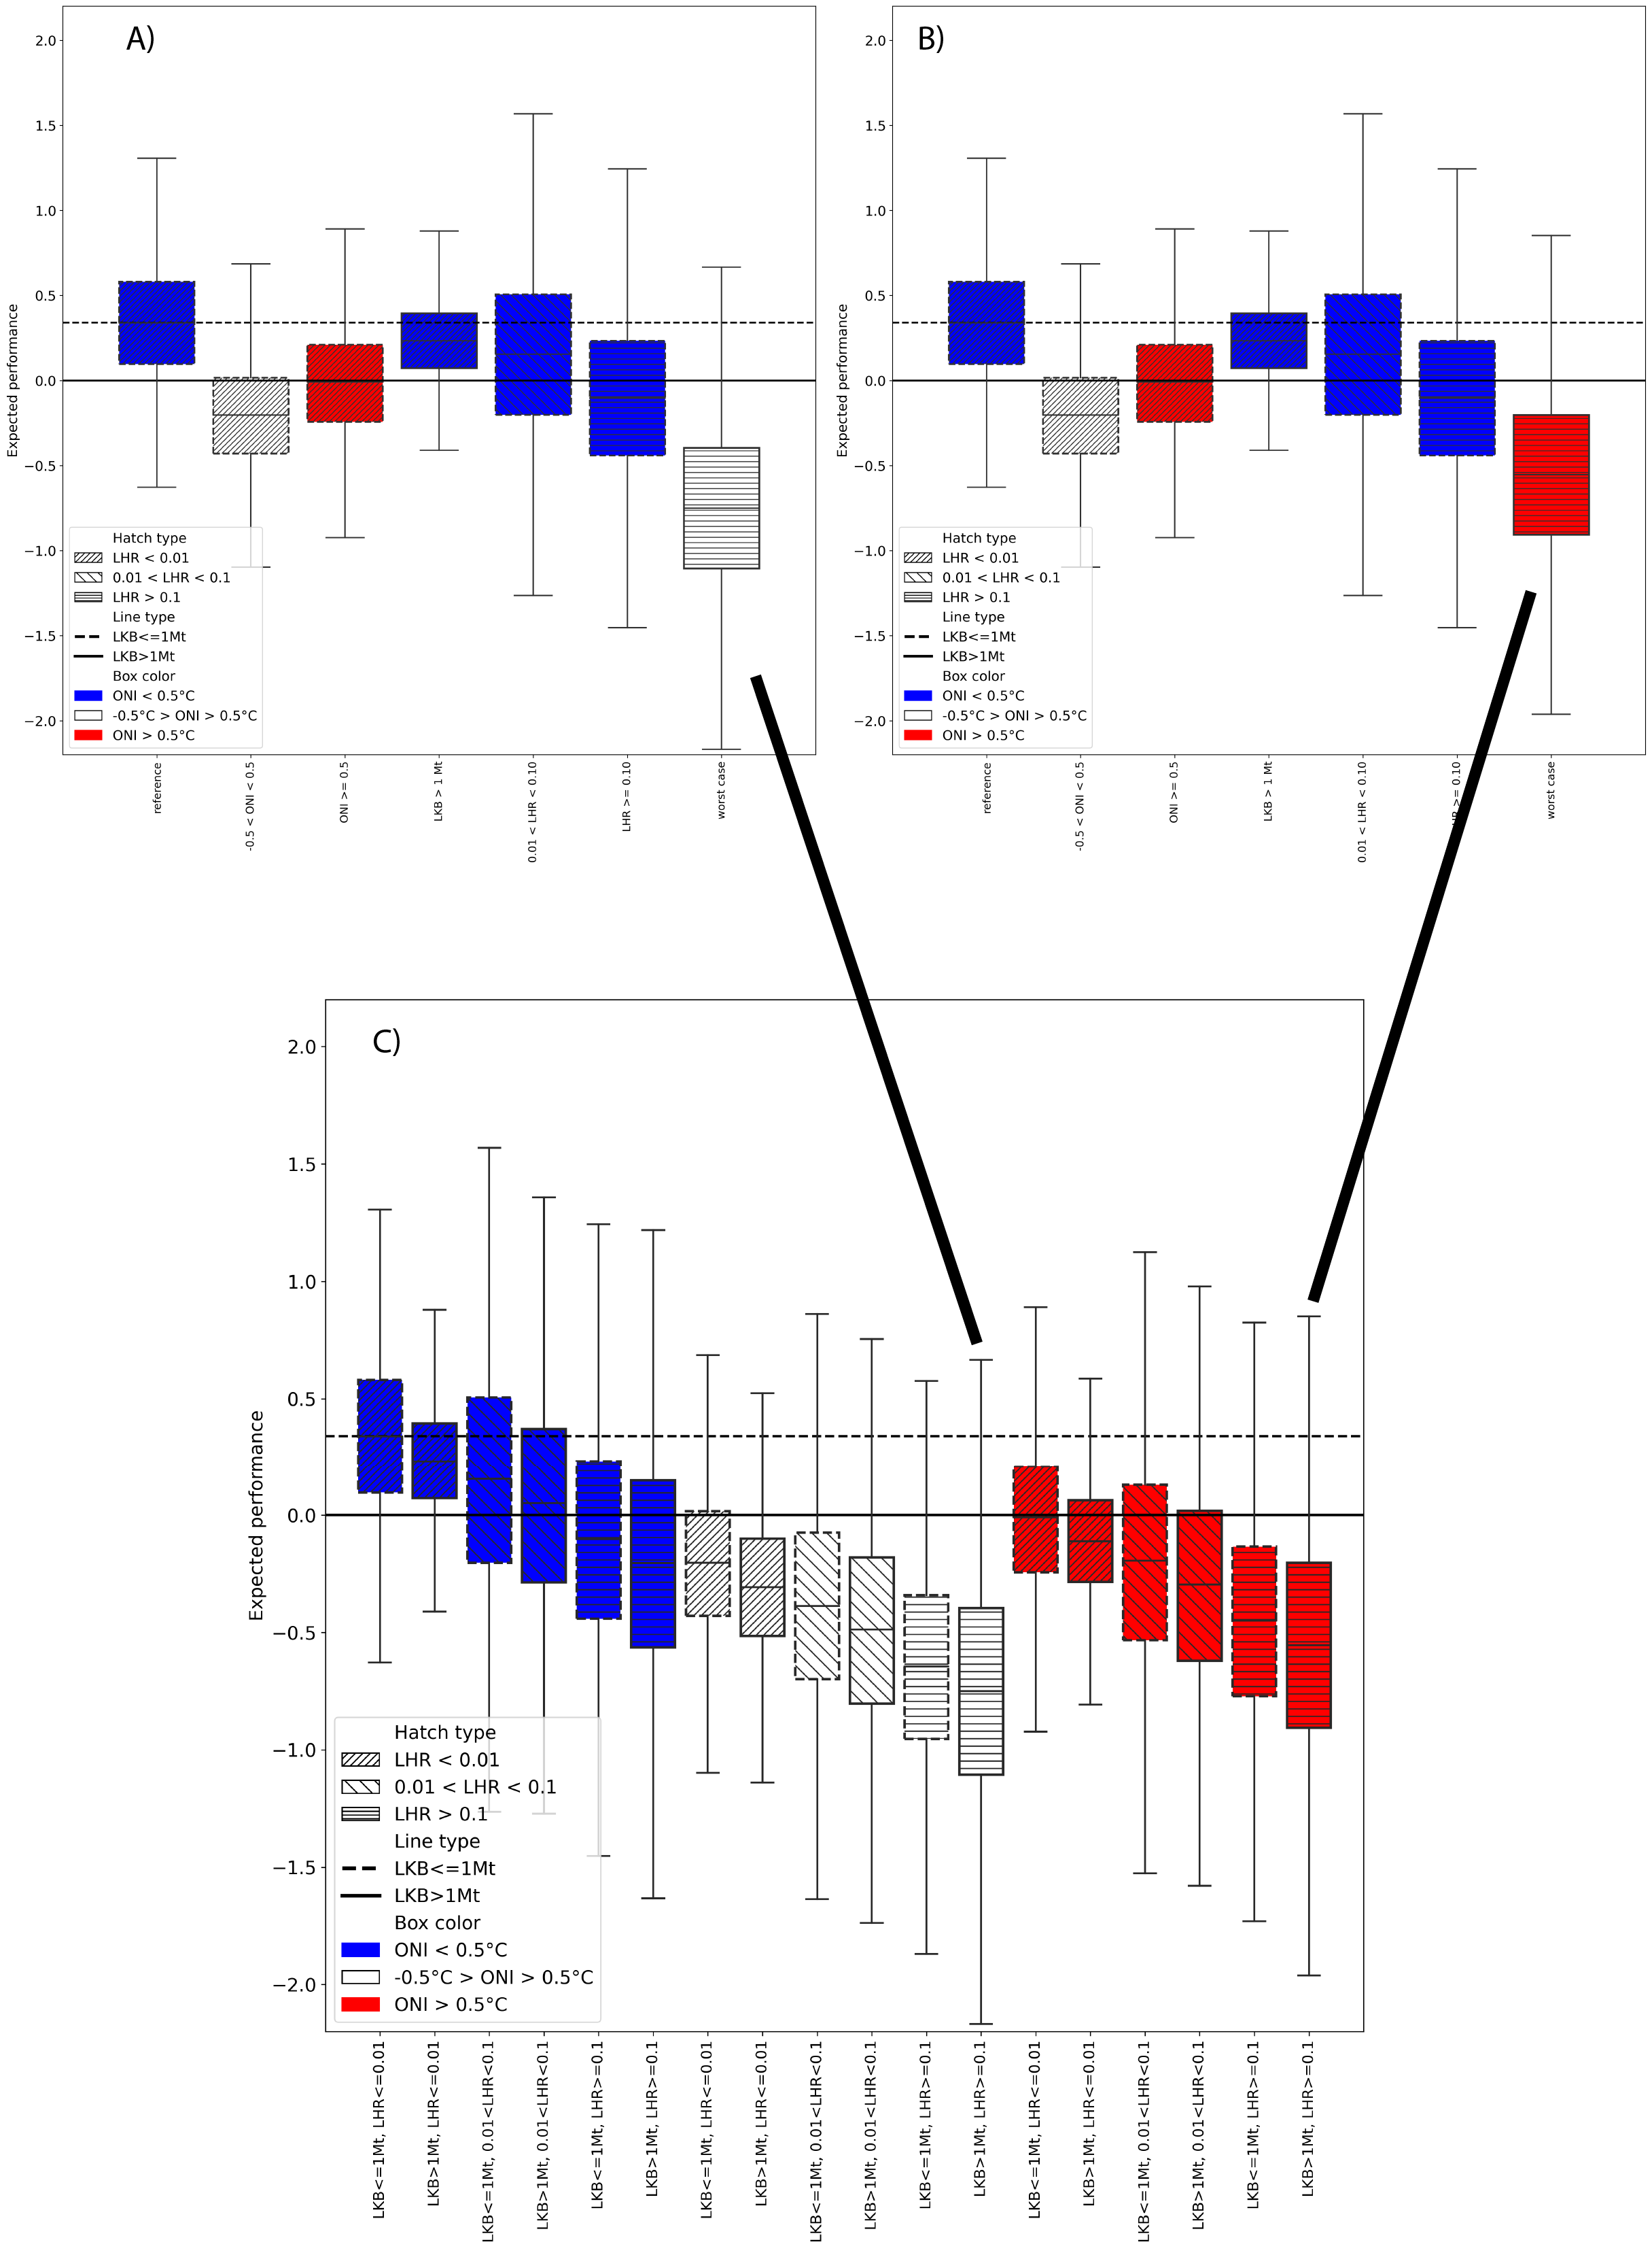

Original Figure 1 plot from Watters et al. 2020 with A) Neutral ONI and B) B) Warm ONI constituting the Worst Case selected. C) Displays the original case-by-case plots recreated from the paper, with Case 12 representing the intention while data from Case 18 was selected for rendering the boxplot. Note that the expected performance under neutral ONI Worst Case is poorer than under the warm ONI that was presented in the original paper. Henceforth, to facilitate comparison, we refer to the ONI Neutral plot however we consider this unrealistic if the intention is to portray a Worst Case of a continuing warming climate.

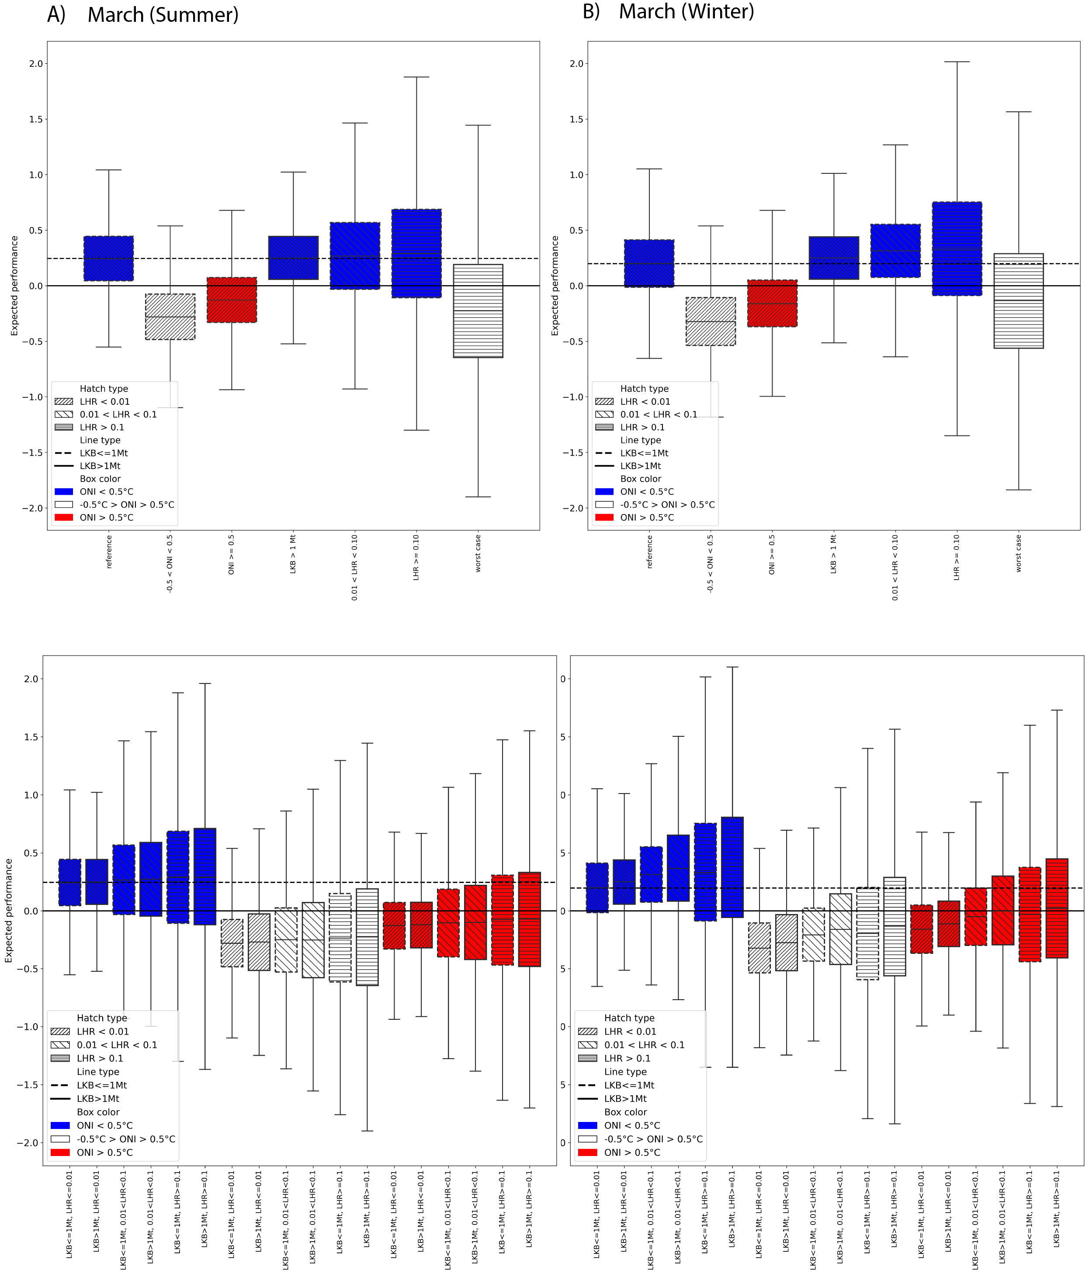

Model output for the alternatve Watters et al. 2020 scenario outlined above (all species initially present, Adélie and chinstrap penguins migrate out of the area after breeding, LKB and LHR rescaled to SSMU and March included in summer or winter). Selected cases as per Watters et al. 2020 for March in A) Summer and B) Winter are provided, with the corresponding case-by-case boxplots presented beneath. Boxplots are colour-coded by ONI state (red=warm, white=neutral, blue=cold). In all cases, the marginal effect of ONI dominated the expected performance of penguins against their long-term mean, irrespective of LKB or LHR.

Original table in Watters et al. 2020. In this and all subsequent tables below, the posterior and posterior predictive probabilities that the expected performance of penguins given the effects in the left hand column are less than the expected performance given the drivers in the column headings are provided. Worst Case is represented by neutral ONI; LHR $≥$ 0.1; and LKB $≥$ 1Mt. The Best Case is represented by La Niña conditions, low LKB and low LHR.

Effects

Best Case

-0.5 $​^{∘}$ C < ONI < +0.5 $​^{∘}$ C

ONI $≥+0.5$

Long-term $μ$

Long-term predicted $μ$

Best case

NA

NA

NA

0.04

0.36

ONI Neutral

1.00

NA

NA

0.89

0.59

ONI warm

0.99

NA

NA

0.52

0.51

LKB High

0.71

0.02

0.12

0.01

0.41

LHR medium

0.75

0.16

0.31

0.32

0.44

LHR high

0.93

0.39

0.61

0.64

0.54

Worst case

0.99

NA

NA

0.99

0.78

Posterior and posterior predictive probabilities extracted from the model output for alternatve Watters et al. 2020 scenario outlined above with March attributed to winter (Adélie and chinstrap penguins migrate out of the area after breeding, LKB and LHR rescaled to SSMU). Under this scenario, performance against the long term mean is worst for neutral and warm ONI conditions.

Effects

Best Case

-0.5 $​^{∘}$ C < ONI < +0.5 $​^{∘}$ C

ONI $≥+0.5$

Long-term $μ$

Long-term predicted $μ$

Best case

NA

NA

NA

0.04

0.40

ONI Neutral

1.00

NA

NA

0.97

0.62

ONI warm

0.99

NA

NA

0.81

0.56

LKB High

0.49

0.01

0.05

0.03

0.40

LHR medium

0.46

0.04

0.09

0.14

0.39

LHR high

0.45

0.10

0.16

0.23

0.39

Worst case

0.84

NA

NA

0.71

0.59

Posterior and posterior predictive probabilities extracted from the model output for alternatve Watters et al. 2020 scenario outlined above with March attributed to summer (Adélie and chinstrap penguins migrate out of the area after breeding, LKB and LHR rescaled to SSMU). Under this scenario performance against the long term mean is also worst for neutral and warm ONI conditions.

Effects

Best Case

-0.5 $​^{∘}$ C < ONI < +0.5 $​^{∘}$ C

ONI $≥+0.5$

Long-term $μ$

Long-term predicted $μ$

Best case

NA

NA

NA

0.10

0.42

ONI Neutral

1.00

NA

NA

0.98

0.63

ONI warm

0.99

NA

NA

0.86

0.56

LKB High

0.40

0.00

0.04

0.03

0.40

LHR medium

0.27

0.01

0.02

0.04

0.37

LHR high

0.37

0.08

0.13

0.21

0.38

Worst case

0.76

NA

NA

0.63

0.55

# Supplementary material

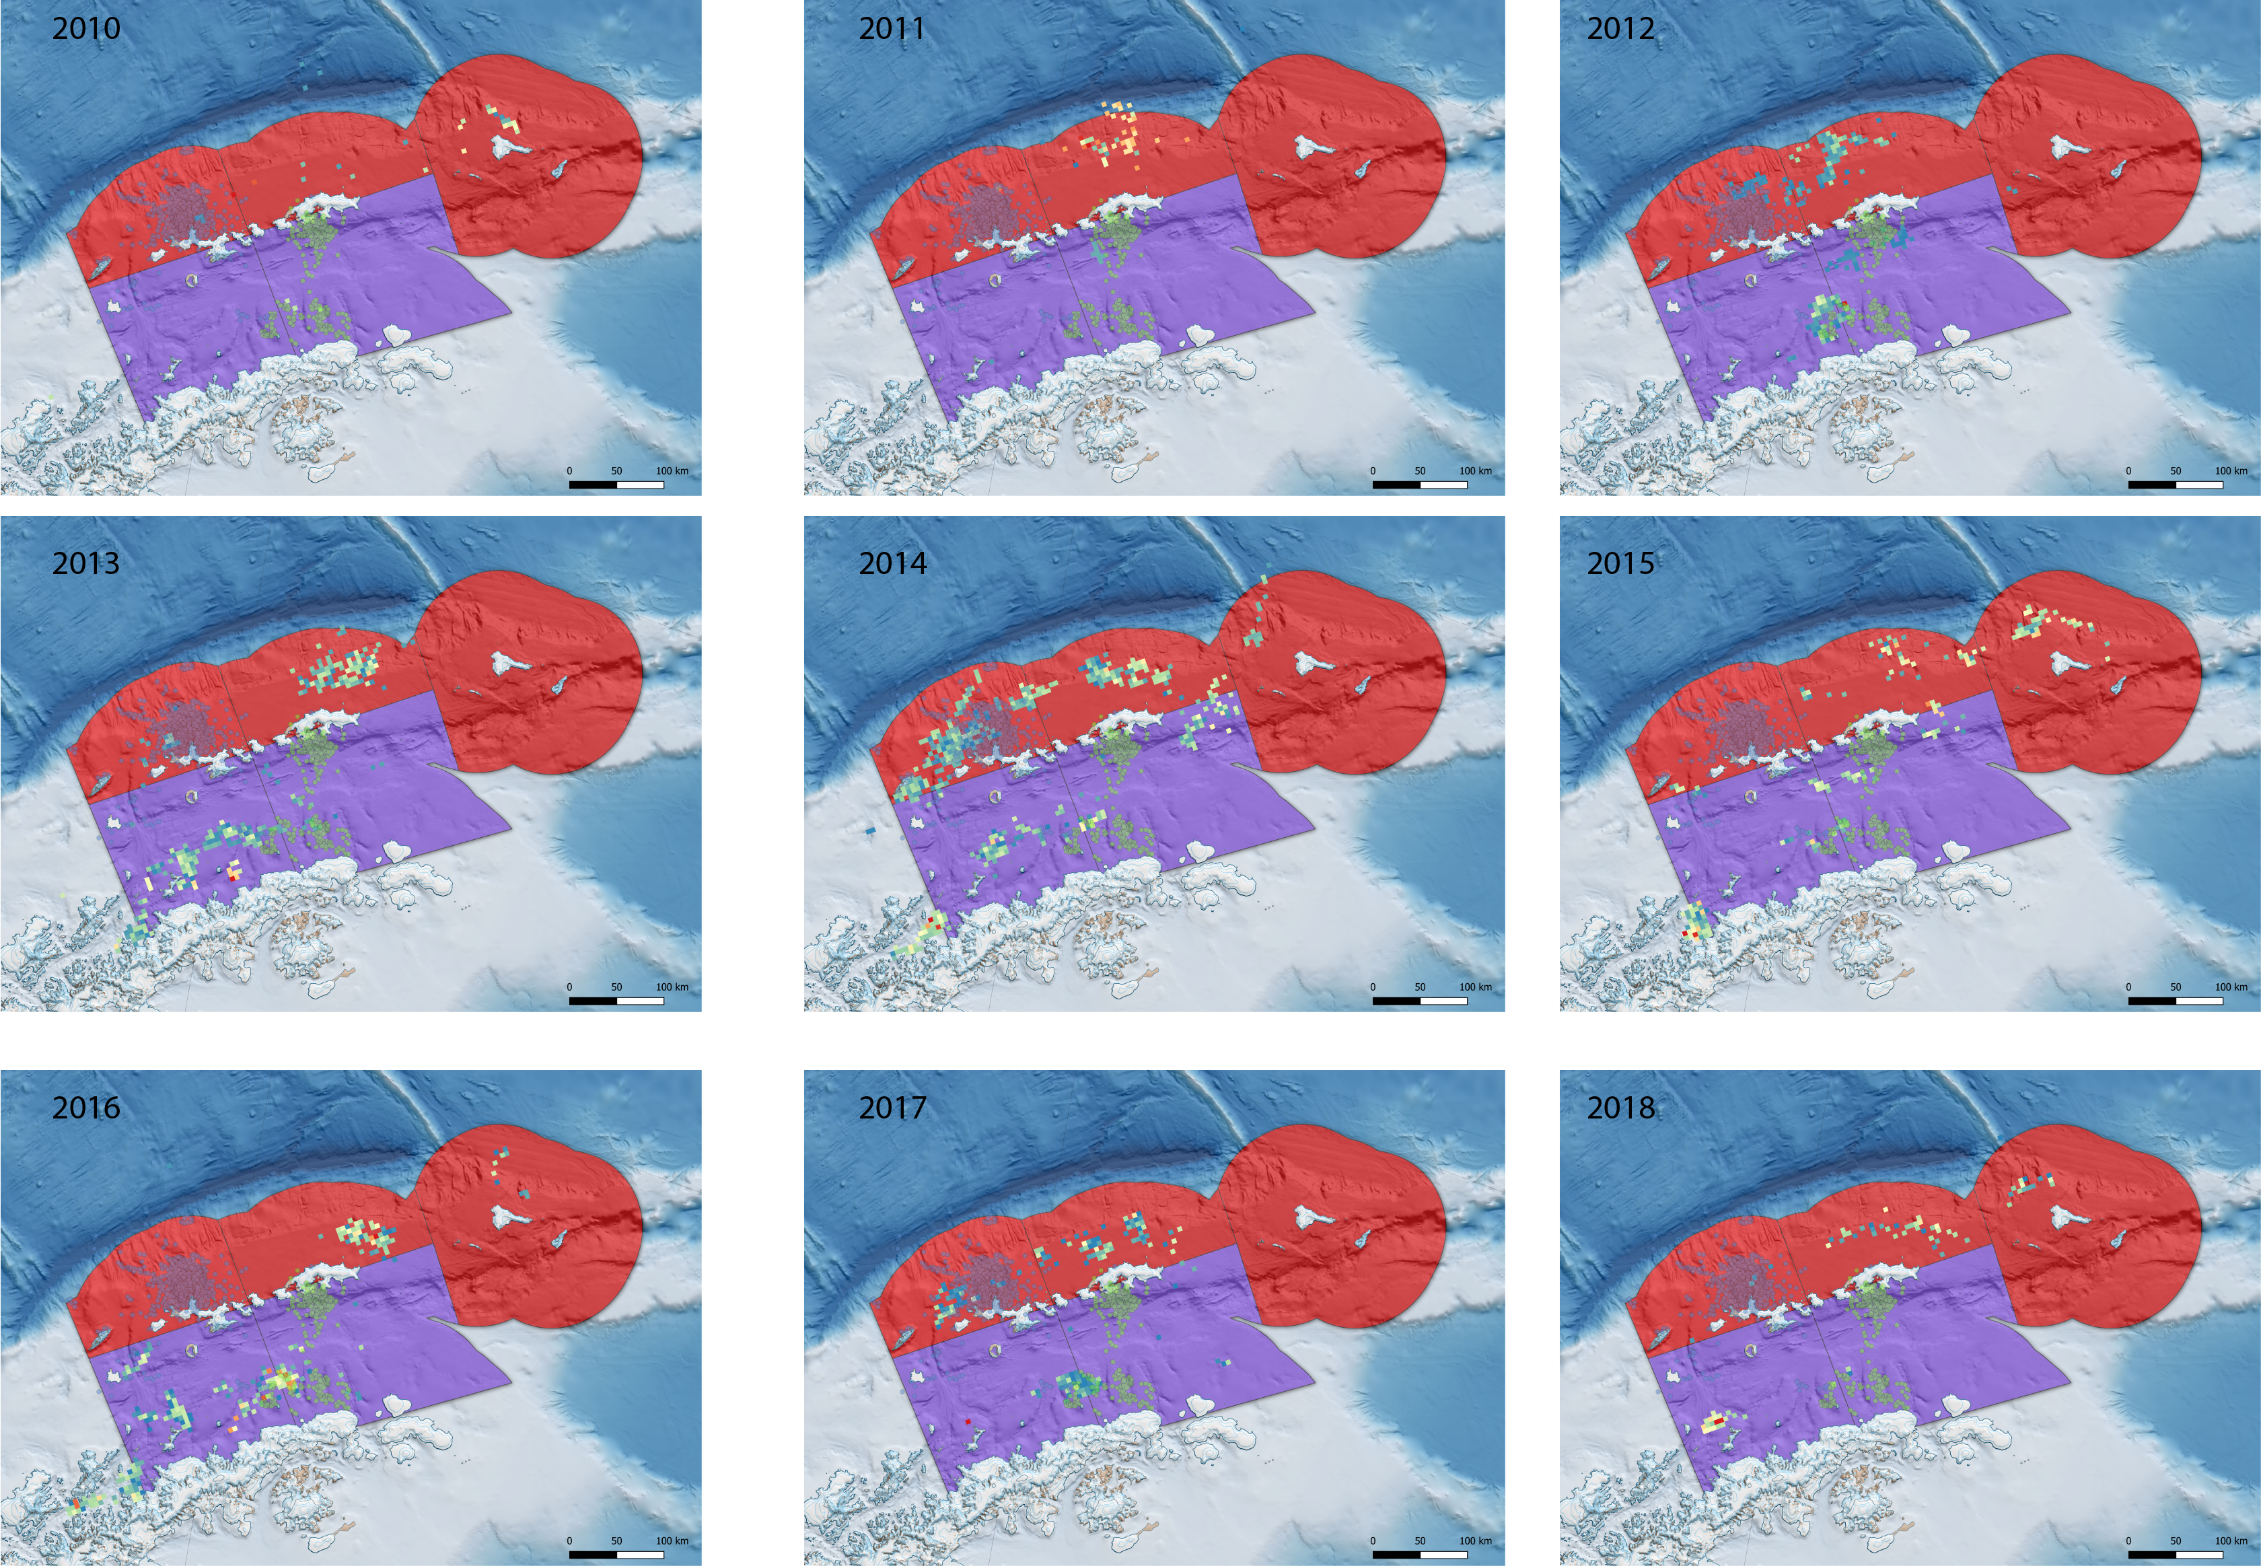

C1 Catch and Effort data for 2010 - 2018, for all catches during the period of the austral summer relating to Adélie and chinstrap penguins in Subarea 48.1 (i.e. up to ${10}^{th}$ March). The telemetry data presented in Hinke et al. 2017 for chinstrap penguins at both Cape Shireff and Copacabana and the gSSMU used in the Watters et al. 2020 paper are superimposed to highlight the extreme variability in actual catch, relative to the scale of LHR used to reflect interactions with penguins. Our reanalysis re-scaled LHR to the SSMU level, though we contend that for the purposes of matching predator data at appropriate spatial scales even this is too coarse a resolution.

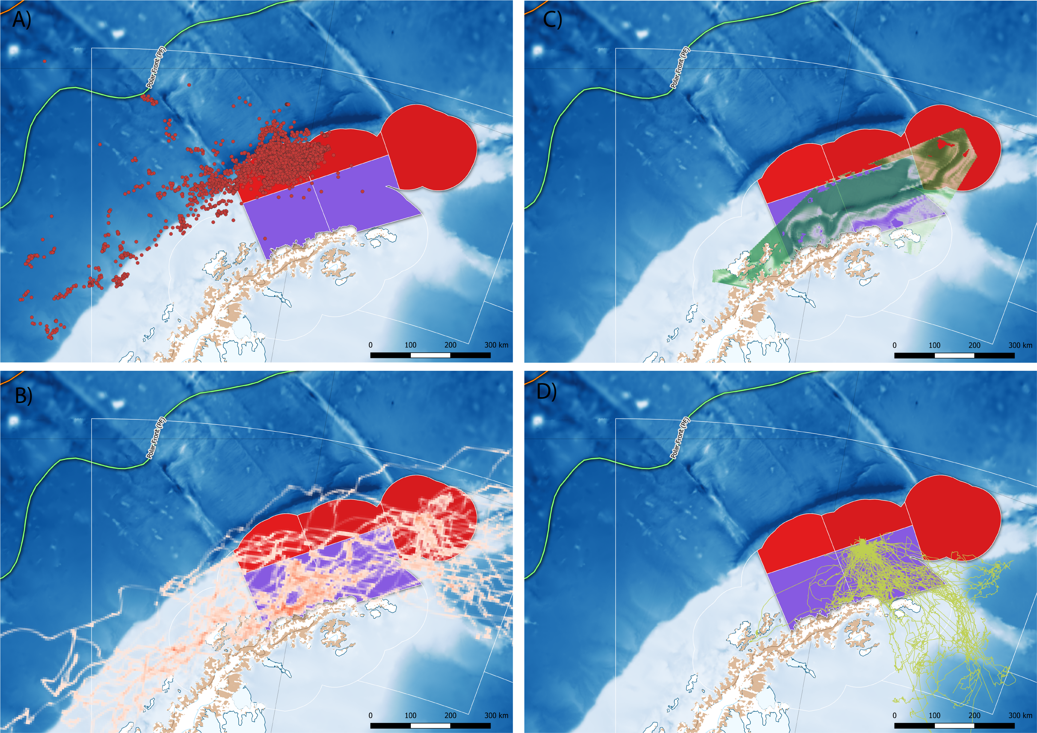

The summer distribution of foraging effort by A) adult female Antarctic fur seals (adapted from telemetry data available in Hinke et al. 2017), B) migratory adult male Antarctic fur seals (adapted from Lowther et al. 2020) C) humpback whales throughout December (adapted from Johannessen et al., this meeting) and D) nonbreeding adult Adélie penguins during the breeding season (adapted from data in Oosthuizen et al., this meeting). Potential effects of competitive overlap between pygoscelid penguins and other krill dependent predators, particularly those who have increased their abundance dramatically over the preceding 40 years, are excluded from both approaches, creating an unrealistic set of boundary conditions for interpreting the variance in penguin vital rates.

# Citations

Watters, George M., Jefferson T. Hinke, and Christian S. Reiss. 2020. “Long-Term Observations from Antarctica Demonstrate That Mismatched Scales of Fisheries Management and Predator-Prey Interaction Lead to Erroneous Conclusions about Precaution.” *Scientific Reports* 10 (1). <https://doi.org/10.1038/s41598-020-59223-9>.